Minor Project Synopsis Report
MindSpace
Project Category: University Based Project
Projexa Team Id- 26E1055

Submitted in partial fulfilment of the requirement of the degree of
BACHELORS OF TECHNOLOGY
in
Computer Science Engineering Core (Section -A)
to
K.R Mangalam University
by

Team - Error_runtime

Under the supervision of

Dr. Shahid Ahmad Wani

Department of Computer Science and Engineering - School of Engineering and Technology
K.R Mangalam University, Gurugram- 122001, India Feburary 2026

INDEX

S.no | Headings | Page No.
1. | Abstract | 3
2. | Introduction (description of broad topic) | 4
3. | Motivation | 5
4. | Literature Review | 6
5. | Gap Analysis | 7
6. | Problem Statement | 8
7. | Objectives | 9
8. | Tools/platform Used | 10-11
9. | Methodology | 12-13
10. | References | 14

ABSTRACT

The current landscape of student mental health monitoring is critically flawed due to its episodic and reactive nature, often relying on sporadic surveys that fail to capture the cumulative progression of burnout . Furthermore, academic datasets utilized for research are frequently compromised by "noisy" data and outliers, leading to skewed analytical results .

MindSpace addresses these systemic inefficiencies by introducing a centralized, full-stack analytical framework designed for high-integrity data management. Unlike static visualization tools, MindSpace implements a robust "Editing Suite" that empowers researchers to ingest large-scale CSV datasets and perform real-time CRUD (Create, Read, Update, Delete) operations, ensuring data accuracy prior to analysis.

The system employs a Python-based Analytical Engine to compute a multidimensional "Burnout Index" and integrates Linguistic Sentiment Analysis (VADER) to detect latent distress in textual feedback. Through automated visualization using heatmaps and trend lines, MindSpace transforms raw academic and lifestyle metrics into actionable insights, enabling the early identification of chronic burnout risks.

KEYWORDS: Student Burnout, Data Integrity, Sentiment Analysis, CRUD Operations, Flask, Predictive Analytics.

INTRODUCTION

In the data-driven era of education, institutions possess vast repositories of student information, yet a significant "intelligence gap" remains regarding student well-being. Traditional Learning Management Systems (LMS) prioritize academic outputs; grades and attendance; while ignoring the critical "inputs" of sleep, stress, and emotional resilience . This results in a blind spot where high-performing students may be suffering from severe, undocumented burnout.

MindSpace is conceptualized as an intelligent bridge between raw data collection and human-centric insight. It is a web-based analytical platform that moves beyond simple reporting to offer a dynamic Data Management Interface. The project is grounded in the understanding that burnout is not a singular event but a complex correlation of lifestyle factors. By aggregating quantitative metrics (e.g., study hours, sleep patterns) with qualitative data (e.g., student feedback), MindSpace creates a holistic profile of student health. The platform’s architecture allows for the continuous ingestion and cleaning of data, shifting the paradigm from reactive crisis management to proactive trend analysis.

MOTIVATION

Our motivation for building MindSpace stems from our own experiences as engineering students. We exist in a culture that often glorifies "the grind";sleepless nights and caffeine-fuelled study sessions are worn as badges of honour. However, we noticed a disturbing pattern: high grades often correlated with deteriorating mental health, yet this correlation was nowhere to be found in our academic records.

We asked ourselves a simple question: If companies use data analytics to predict when a machine is about to break, why can't we use data to predict when a student is about to break?

The primary impetus for developing MindSpace stems from the pervasive issue of "dirty data" in mental health research. We observed that datasets regarding student stress are often plagued by anomalies;such as unrealistic sleep hours or exaggerated stress scores;which compromise the integrity of any subsequent analysis . There is a critical need for a tool that not only visualizes data but empowers researchers to interact with and correct it in real-time.
Furthermore, we were motivated to operationalize "empathy" within data science. Standard metrics often fail to capture the nuance of human distress. A student might rate their stress as a "5/10" but describe feeling "overwhelmed and hopeless" in text. By integrating Natural Language Processing (NLP), specifically Sentiment Analysis, we aim to uncover these hidden narratives . This project represents a shift towards "Human-in-the-Loop" analytics, where the precision of algorithms meets the interpretative needs of educators.

LITERATURE REVIEW

Academic Performance vs. Mental Health: Extensive research exists linking sleep deprivation to lower cognitive function, yet few practical tools integrate this relationship into academic tracking. Studies utilizing the Student Stress Dataset (Kaggle) have mathematically demonstrated that stress is a function of multiple variables, not a standalone metric. MindSpace operationalizes these findings by creating a weighted algorithm that balances study load against recovery time (sleep).

Sentiment Analysis in Education: The field of Educational Data Mining (EDM) is increasingly looking at unstructured data. Research papers on the VADER (Valence Aware Dictionary and sentiment Reasoner) lexicon have shown its effectiveness in analysing social media text. By applying VADER to the educational context;specifically student feedback forms;we can detect emotional polarity without the need for invasive surveillance or complex deep learning models that require massive computational power.

Limitations of Current Systems: Most "Early Warning Systems" in universities are based purely on grade progression. A study by Shariful et al. on Student Mental Health highlights that by the time grades drop, the student is often already in a state of crisis. MindSpace aims to shift the focus to leading indicators (lifestyle and sentiment) rather than lagging indicators (grades).

Table: Sample of Literature Review Table:

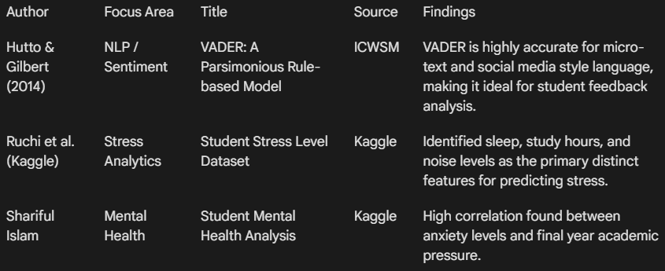

GAP ANALYSIS
1. The Interactivity Gap: Most existing analytical tools are "read-only" dashboards that visualize static historical data. They lack the capability for users to modify incorrect records on the fly. MindSpace fills this gap by integrating a full Editing Suite, allowing for the dynamic correction of data anomalies.
2. The Dimensionality Gap: Current systems operate in silos: Academic portals track grades, while wellness apps track mood. There is a lack of unified frameworks that correlate these dimensions. MindSpace addresses this by computing a "Burnout Index" that mathematically weights academic pressure against lifestyle recovery factors.
3. The Qualitative Gap: While numerical data is tracked rigorously, textual data is often ignored. Existing tools rarely apply NLP to student feedback. MindSpace bridges this gap by embedding a Sentiment Engine directly into the analytical pipeline .

PROBLEM STATEMENT

The academic sector currently lacks a unified, intelligent framework for monitoring student well-being. The specific technical and operational problems addressed by this project include:
- Episodic Monitoring: Mental health assessments are conducted sporadically (e.g., once a semester), failing to capture the daily fluctuations of student stress .
- Data Reliability: Research datasets are often contaminated with outliers and errors, which existing tools cannot easily rectify without external software .
- Analysis Latency: The time lag between data collection and actionable insight is too long. Educators need real-time visualization of risk trends to intervene effectively.
- Silent Distress: Students often mask their distress in surveys but reveal it in written feedback. Current systems lack the linguistic capability to decode these warning signs.

OBJECTIVES

The project aims to develop a robust, full-stack analytical solution with the following specific objectives:
- To Engineer a Data Management Interface: Develop a secure Flask-based portal that supports the ingestion of CSV/Excel datasets and enables CRUD (Create, Read, Update, Delete) operations for ensuring high-fidelity data integrity.
- To Formulate a Burnout Index: Implement a Python-based algorithm that correlates lifestyle factors (Sleep, Study Load) with psychological metrics (Stress Levels) to compute a standardized risk score for every student.
- To Integrate Sentiment Analysis: Deploy the NLTK VADER lexicon to process unstructured text data, generating "Mood Scores" that quantify the emotional tone of student feedback.
- To Visualize Risk Distribution: Create a dynamic dashboard using Seaborn/Matplotlib that generates real-time heatmaps and scatter plots, visually identifying the correlation between high academic pressure and mental exhaustion.

The MindSpace application delivers a fully functional web tool capable of:

- Quantitative & Qualitative Synthesis: Generating numerical burnout scores alongside sentiment insights.
- Visual Risk Profiling: Producing interactive distributions and risk category proportions.
- Iterative Management: Providing editable data capabilities, allowing researchers to refine datasets and re-process results in real-time.
- Deployment Readiness: A modular architecture designed for local execution with scalability for cloud deployment.

Tools/Technologies Used

- Python: Chosen for its dominance in data science and extensive library ecosystem.
- Flask (Web Framework): Selected for its lightweight, modular design, allowing for the rapid development of RESTful routes to handle data requests and render templates.
- Pandas & NumPy: Utilized for high-performance data manipulation, specifically for cleaning large datasets and performing vectorized calculations for the Burnout Index.
- NLTK (VADER): The core of the Sentiment Engine. VADER was chosen for its rule-based efficiency in analysing sentiment intensity without the computational overhead of deep learning models.
- SQLite: Implemented for lightweight, server-side session management and temporary storage of edited datasets.
- Matplotlib / Seaborn: Used for generating static and interactive statistical graphics to visualize burnout trends.

Reasons for Selecting this language:

Backend Framework: Flask (Python)

Role: Handles server-side routing (/upload, /dashboard), request processing, and Jinja2 template rendering.

Reason for Choice: We chose Flask over heavier frameworks (like Django) because of its lightweight, unopinionated nature. It follows the Model-View-Controller (MVC) pattern, allowing us to rapidly prototype the "Editing Suite" and map Python functions directly to HTML endpoints without unnecessary boilerplate code.

Data Processing: Pandas & NumPy

Role: The "Data Engine" utilizes Pandas for CSV manipulation and NumPy for numerical clipping.

Reason for Choice: Educational datasets are often "noisy." Pandas allows us to treat CSV files like SQL tables;filtering outliers and performing vectorized calculations for the Burnout Score formula efficiently, which would be slow and complex using standard Python loops.

Natural Language Processing: NLTK (VADER)

Role: The "Sentiment Engine" utilizes the VADER lexicon to score student feedback.

Reason for Choice: Unlike deep learning models (e.g., BERT) which require massive computational resources and training data, VADER is a rule-based model. It is computationally efficient and specifically tuned for informal text (slang, emojis), making it ideal for analysing student comments in real-time.

Visualization: Matplotlib

Role: Generates static histograms and pie charts saved as PNG assets.

Reason for Choice: Matplotlib provides granular control over statistical plots. By rendering plots on the server side, we ensure consistent visualization across all client browsers without relying on heavy client-side JavaScript libraries.

Frontend: HTML5, CSS3, Jinja2

Role: Provides the responsive user interface.

Reason for Choice: Jinja2 templating allows us to inject Python data directly into HTML, creating a seamless link between the backend analytics and the frontend display.

METHODOLOGY

The development of MindSpace follows an Applied Research Design, combining software engineering principles with quantitative and qualitative data analysis. The methodology is executed in four distinct phases:
Phase 1: Data Ingestion & Validation
The system is designed to process CSV files containing four specific vectors: sleep_hours, study_hours, stress_level (1-10), and feedback.
- Ingestion: The Flask file handler accepts the dataset via the web portal.
- Validation: A pre-processing script verifies column integrity and sanitizes textual data (converting feedback to string format) to prevent processing errors.
Phase 2: The Burnout Algorithm (Quantitative Analysis)
Once validated, the Data Engine computes a unique risk metric for every student using a custom weighted formula:
- Normalization: Using NumPy, this score is clipped to a standard range of 0-100.
- Risk Classification: The pandas.cut() function automatically segments students into risk categories: Low (0-33), Medium (33-66), and High (66-100).
Phase 3: Sentiment Analysis (Qualitative Analysis)
Simultaneously, the text data is processed by the Sentiment Engine.
- Lexicon Mapping: The NLTK SentimentIntensityAnalyzer scans the feedback column.
- Scoring: It assigns a Compound Polarity Score ranging from -1.0 (Negative) to +1.0 (Positive). This metric serves as a "sanity check" against the numerical burnout score;identifying students who may report low stress numerically but express high distress linguistically.
Phase 4: Visualization & Testing
The final processed data is visualized through the Dashboard Module:
- Histograms are generated to show the population distribution of burnout scores.
- Pie Charts visualize the proportional split of risk categories.
- Testing Strategy: The system undergoes Unit Testing (verifying the math of the burnout formula) and Integration Testing (ensuring the upload-to-dashboard pipeline functions without latency).

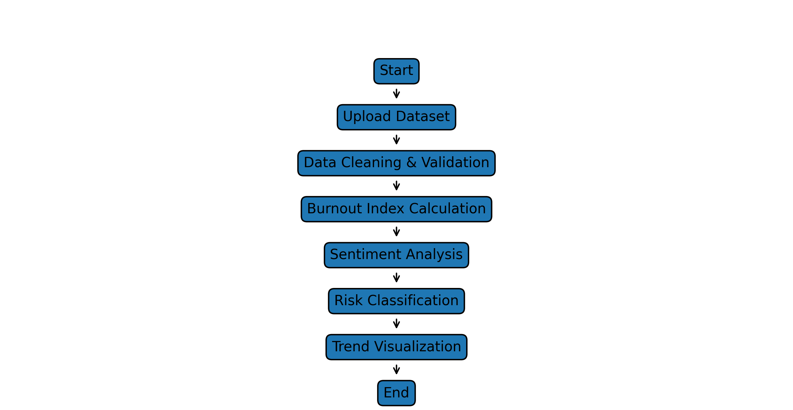

Figure 1: Working Architectural Diagram ( Mandatory)

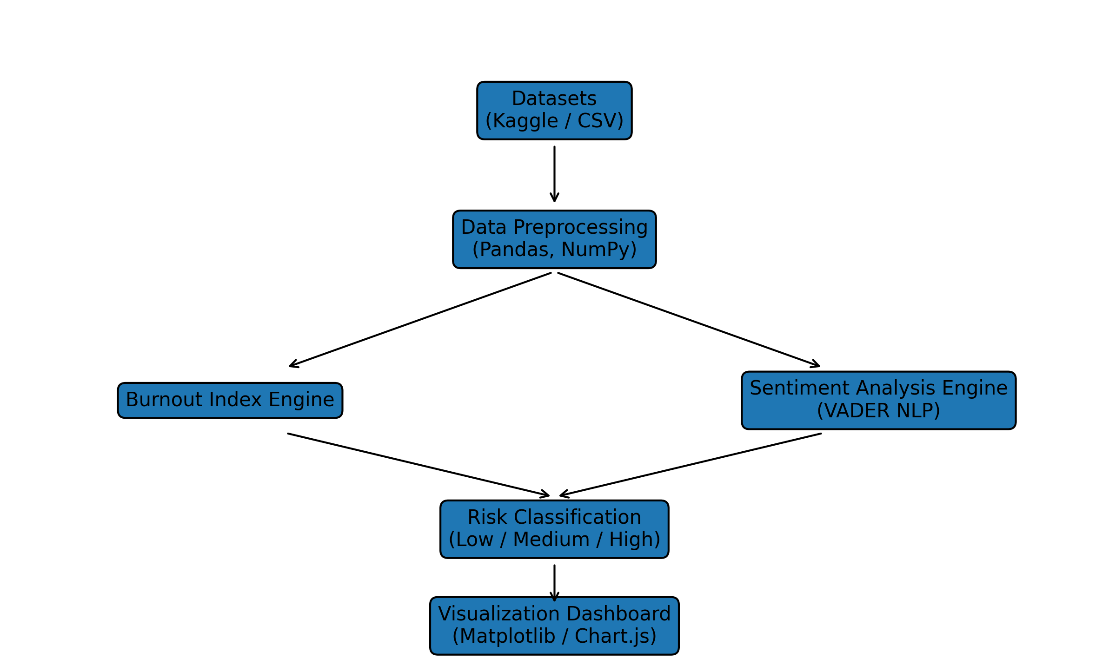
Figure 2: Data Analysis Diagram ( Mandatory)

REFERENCES

- Flask Documentation. Pallets Projects. Retrieved from https://flask.palletsprojects.com.
- Pandas Documentation. PyData. Retrieved from https://pandas.pydata.org.
- Hutto, C.J. & Gilbert, E.E. (2014). VADER: A Parsimonious Rule-based Model for Sentiment Analysis of Social Media Text. Eighth International AAAI Conference on Weblogs and Social Media.
- Student Stress Dataset. Kaggle. Retrieved from https://www.kaggle.com/datasets/ruchi798/student-stress-level.
- Student Mental Health Dataset. Kaggle. Retrieved from https://www.kaggle.com/datasets/shariful07/student-mental-health.
- Bird, S., Klein, E., & Loper, E. (2009). Natural Language Processing with Python. O'Reilly Media Inc.

